# COMPUTER SCIENCE & ENGINEERING

**Experiment No. 6** **Experiment Title: KNN**

**Student Name:** YANA SRIVASTAVA **UID:** 20BCS2279

**Branch:** CSE **Section/Group:** 20BCS-WM-906/B

**Semester:** 5th **Date of Performance:** 28/10/22

**Subject Name:** Machine Learning Lab **Subject Code:** 21CSP-317

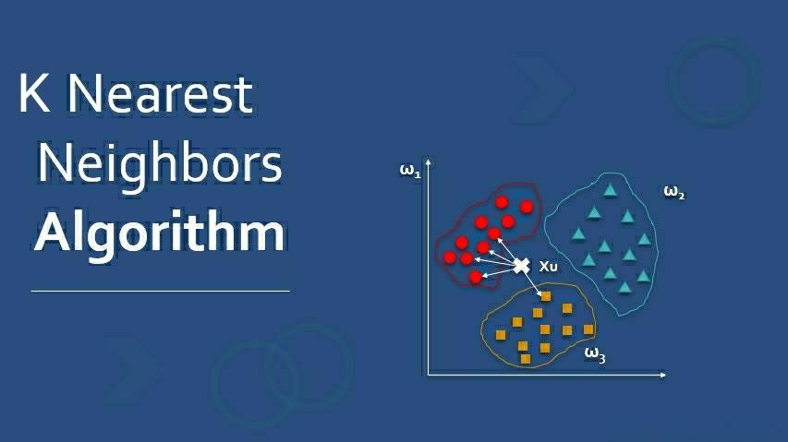

## Aim/Overview of the practical:

Implementation of KNN (k Nearest Neighbors) Algorithm.

## Steps of Experiment:

* + Import all the required library.
  + Import the dataset which you want to implement.
  + Split data into x and y and perform some task.
  + Split data into training set and testing set.
  + Apply KNN Algorithm.

# COMPUTER SCIENCE & ENGINEERING



1. **Source Code/Result/Output:**

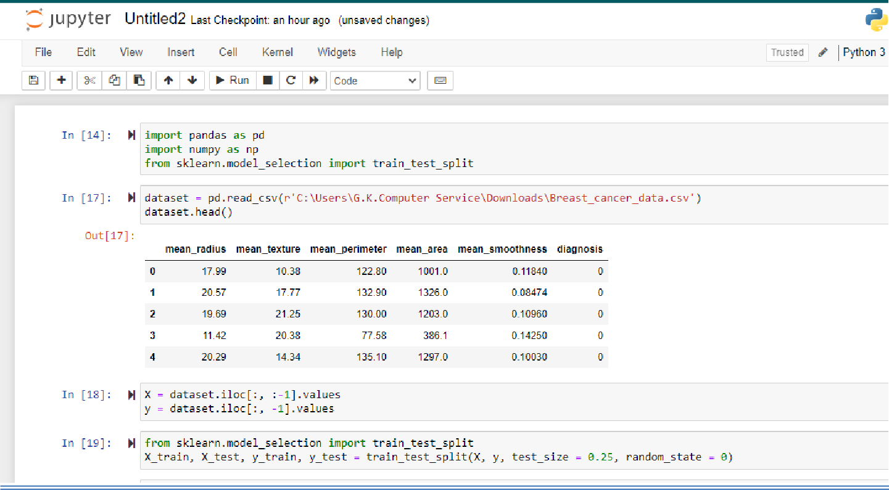

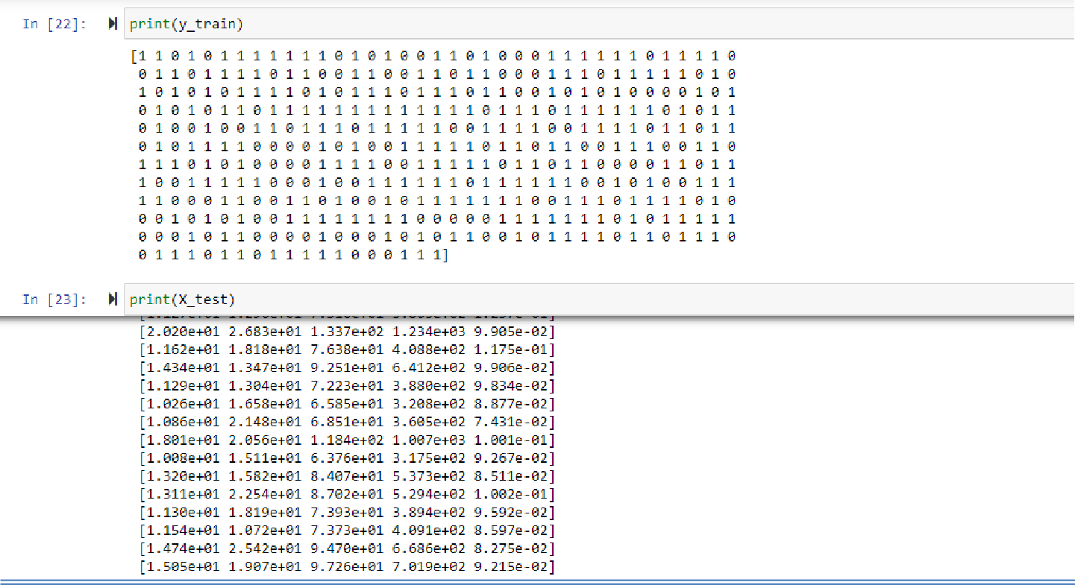

# COMPUTER SCIENCE & ENGINEERING



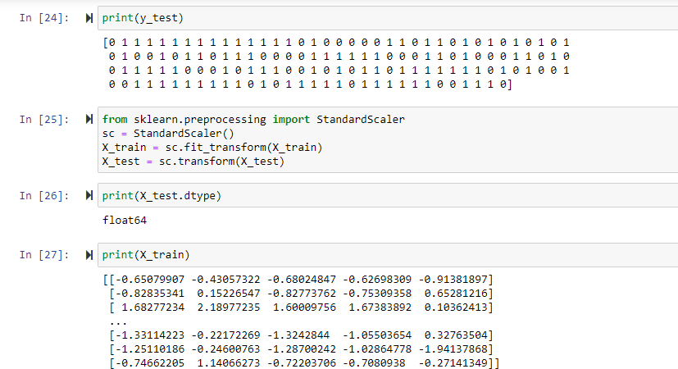

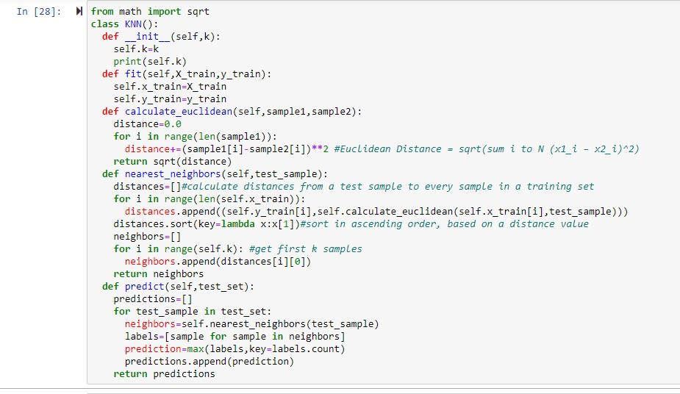

COMPUTER SCIENCE & ENGINEERING



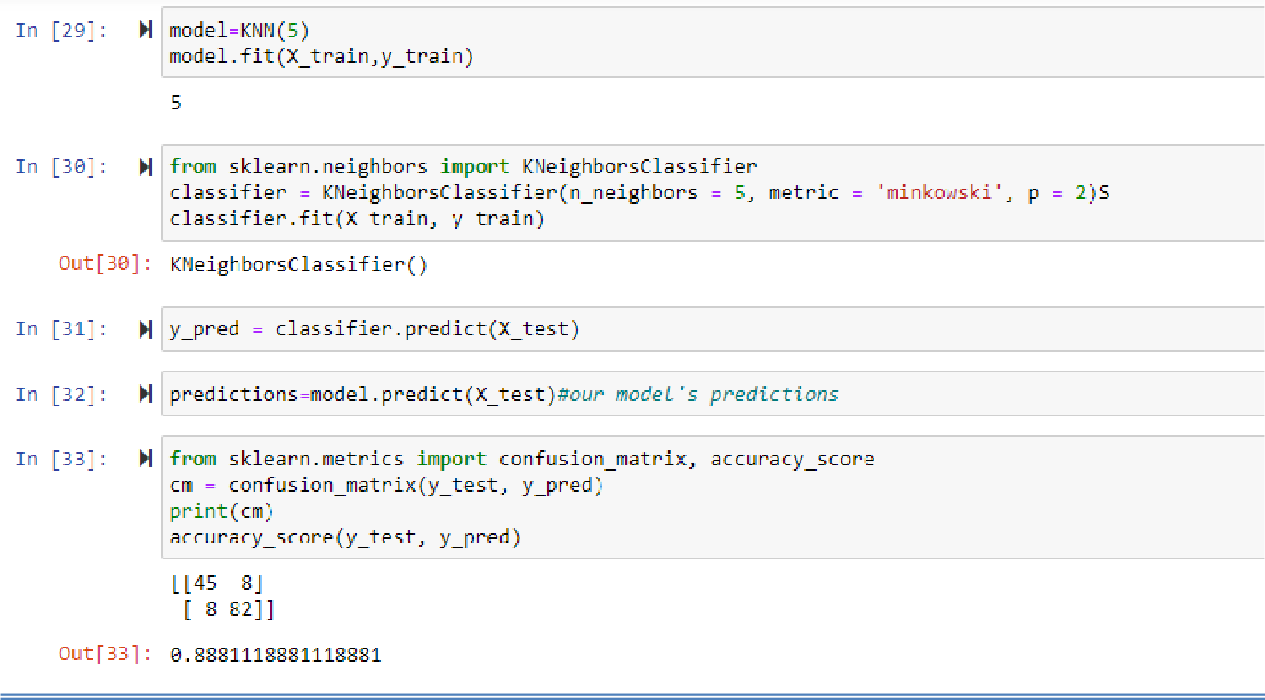

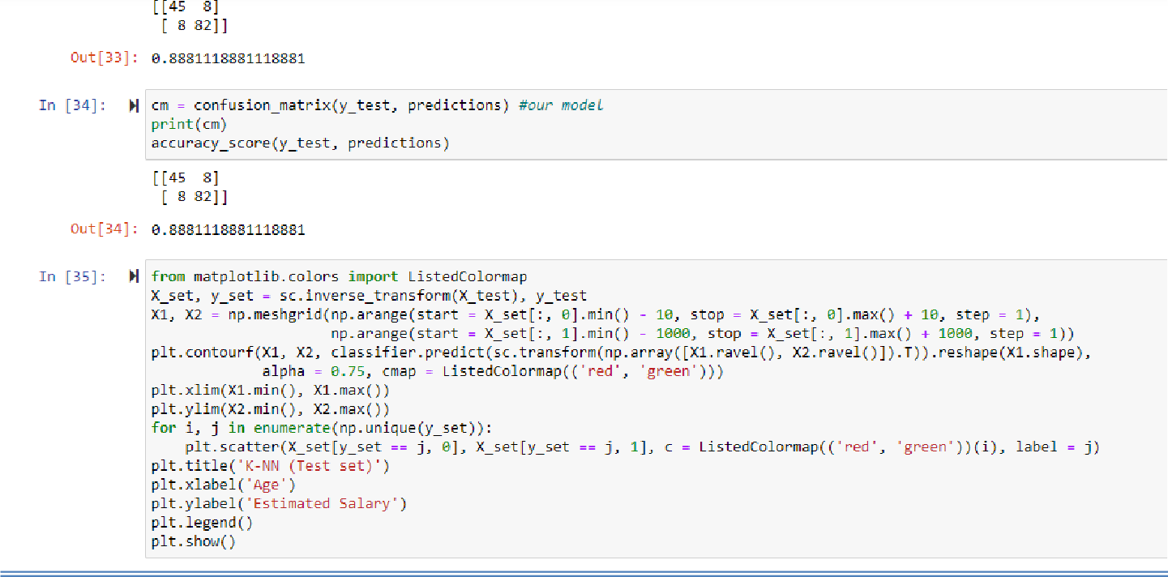

# COMPUTER SCIENCE & ENGINEERING



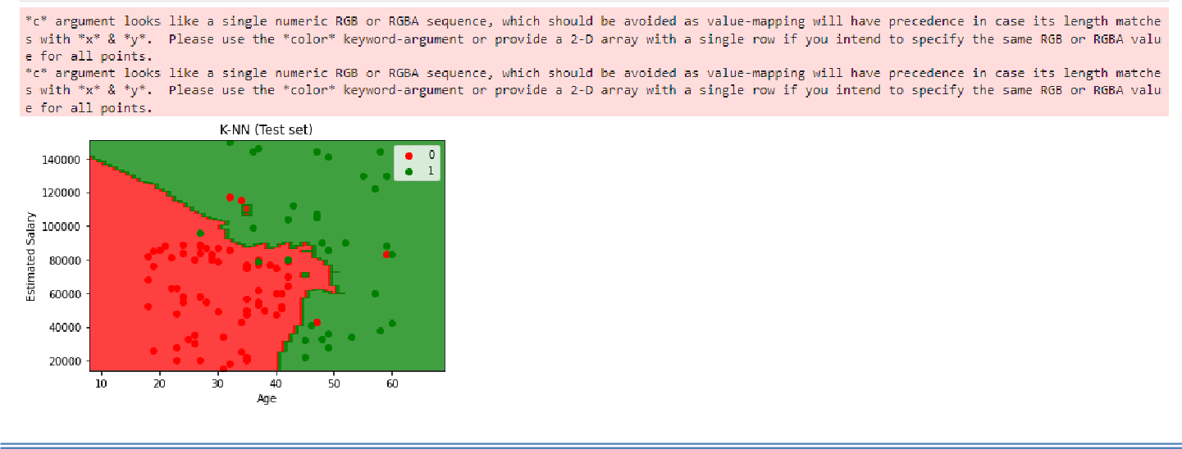

## Learning outcomes (What I have learnt):

### Learnt to analyze the data.

1. **Learnt to import various libraries.**

### Learnt to read csv files.

1. **Learnt to train and test the data.**

### Learnt the concept of KNN (K – Nearest Neighbors).

**Evaluation Grid:**

|  |  |  |  |
| --- | --- | --- | --- |
| **Sr. No.** | **Parameters** | **Marks Obtained** | **Maximum Marks** |
| **1.** | **Student Performance  (Conduct of experiment) objectives/Outcomes.** |  | **12** |
| **2.** | **Viva Voce** |  | **10** |
| **3.** | **Submission of Work Sheet (Record)** |  | **8** |
|  | **Total** |  | **30** |